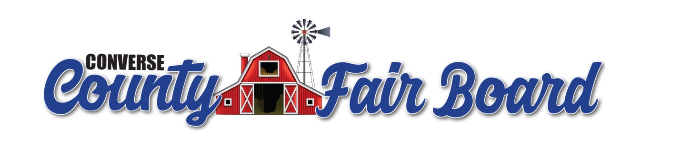
Meeting Minutes
April 9th, 2025

The meeting was called to order at 5:34 PM by Chairman, Stacey Etchemendy. In addition to Stacey Etchemendy, those in attendance were:
Jim Dona – Vise Chairman
Nick Ladd – Secretary
Karmin Addleman – Treasurer/ Youth Rodeo Superintendent
Kelsey Stephens – Fair Manager
Reba Talbot - Sponsorship

- Minutes from last meeting Board Secretary: Nick Ladd
  - Karmin motioned to approve minutes as distributed, Jim seconded, and the motion passed unanimously.
- Treasurer update Treasurer: Karmin Addleman
    - Balances as of March 31, 2025
    - Operating Account - $179,730.93
    - Clearing Account - $33,877.55
      - Bills Presented
        - Bills
          - Dollys (March) - $150.00
          - Stock Contractor $22,500
        - Nick made a motion to approve expenses and file the treasurers report for audit, Karmin seconded, and the motion carried.
- Update from 4-H Educator – Discussion of a 4-H silent auction static sale was presented, but not voted to approve at this time. None
- Update from Glenrock FFA – None
- Update from Douglas FFA – None
- Update from State Fair – None
- Update from Committees
    - Superintendents Fair Manager: Kelsey Stephens
    - Youth Rodeo –
    - Family Fun Night – None
    - PRCA Xtreme Broncs Expenses – Big Screen for event $5,500
      - Jim made a motion to approve expenses, Karmin seconded, and the motion carried.

    - Ranch Rodeo Expenses – Rough Stock $2,000 Contractors $1,450.
Nick made a motion to approve expenses, Jim seconded, and the motion carried.

    - Judges - None Representative: Karmin, Stacey & Tia
Old Business – No unresolved.
Executive Session – None.

New Business
- Sponsorship Update – None
- Commercial Heifer show.
  - A commercial heifer show was presented to the CCFB. Jim made a motion to add it, Karmin seconded, and motion passed.
    - In addition to the show it was discussed that the cow calf pairs need to be halter broke. Nick made a motion to set this guideline, Jim seconded, and the motion passed.
- Event Coordinator (Intern)
  - Create contract for an intern to work as an event coordinator.
- Wyoming State Fair contract meeting 4/18/2025 time TBD

Next meeting will take place May 14th, 5:30pm at the Converse County Fair office.

Chairman Stacey Etchemendy adjourned the meeting at 7:10p.m.

